SELLICKS BEACH HISTORIC MOTORCYCLE RACES 2023
Official Merchandise PRE Order Form
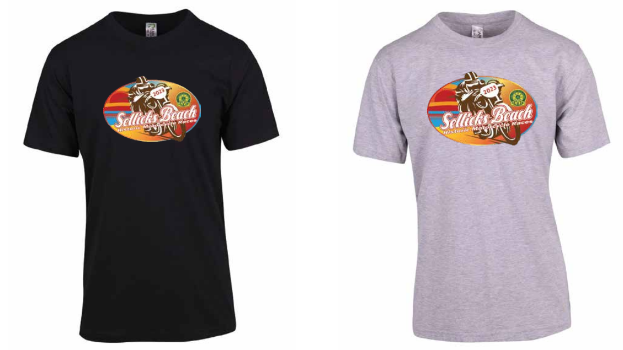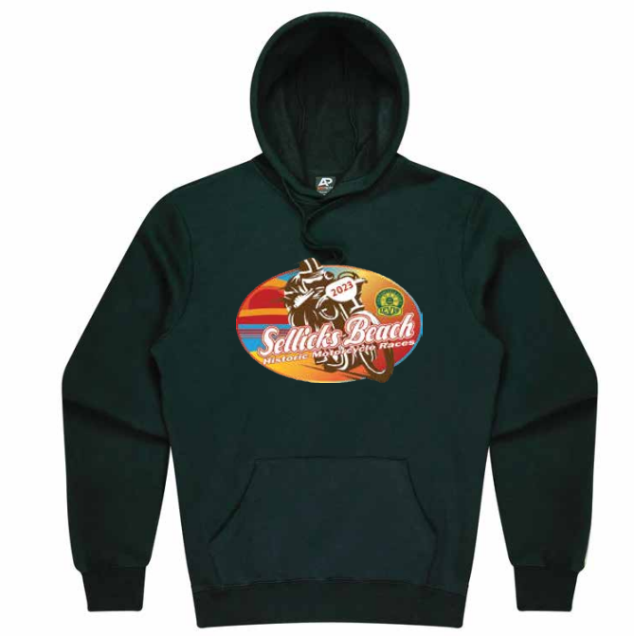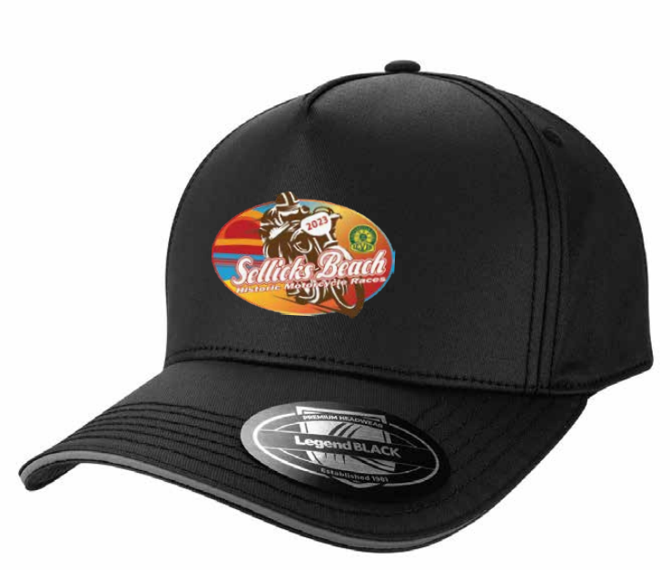
Unisex T Shirt (Black or Merle Grey) Hoodie Cap (Adjustable)
Unisex T Shirt
Kids $20.00 each (Black only)
Size | 6 | 10
Half chest | 37.5cm | 42.5cm
Qty Required
Adults $30.00 each
Size | S | M | L | XL | 2XL | 3XL | 5XL
CM | 52 | 54.5 | 57 | 60 | 63 | 65.5 | 70.5
Qty Black
Qty Grey

Unisex Hoodie $60 each (Black only)
The chart below shows the 1/2 chest measurement. Please allow variation +/- 1cm
SIZE | S | M | L | XL | 2XL | 3XL | 5XL
 | 56CM | 58.5CM | 61CM | 63.5CM | 66CM | 71CM | 76CM
Qty Required

Cap $25.00
Qty Required
----------------------------------------------------------------------------------------------------------------------------------------------------------
SUMMARY only – Please complete above and carry forward details to calculate total purchase total below.
Email Full Form to: treasurer@levismcc.asn.au Subject: Sellicks 2023 Merch Order.
Or Mail to PO Box 274 St Agnes 5097
Payments to: Levis Motorcycle Club BSB 105-056 Account 237789640 Ref: Name (on Order)
Item | Quantity | Cost per each | Total
T Shirt (Kids) |  | $20.00 | $
T Shirt |  | $30.00 | $
Hoodie |  | $60.00 | $
Cap |  | $25.00 | $
**T Shirt and Cap Combo | 1 T Shirt & 1 Cap | $50.00 | $
Postage |  |  | $13.50
Grand Total to be paid. |  |  | $

Name:____________________________________________Phone No:___________________________
Address:__________________________________________________________State________Post Code:______

