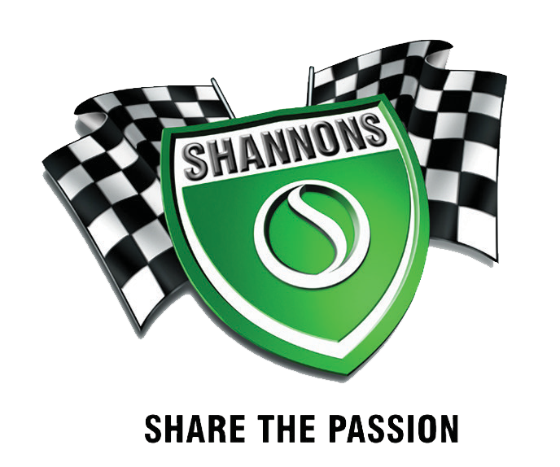

AMBERLIGHT TO BIERHAUS SHOW & SHINE 2024 TROPHY WINNERS

Naked/Café Racer 2006 Triumph T100 Greg Rachmananoff

Sports 1984 Yamama RZ500 Fred Corscadden

Classic 1979 Yamaha XS100 Phil Farmer

Trail / Motard 2023 KTM 500 EXC Matt Cartwright

Cruiser 2014 Indian John Campbell

Adventure 2005 BMW 650 Dakar Louis Peilschmidt

Kids 2002 Honda XR 80 Hudson Sharp

Chopper / Bobber 2013 Harley G.Firmager

Sidecar 1970 BSA Mark Toohey

Vintage 1930 Ariel Geoff Eardley

Scooter 1981 Suzuki FA50 Mika Matthews

Paintwork 2015 Harley Len Kilworth

BEST ON SHOW 2013 Harley G. Firmager

Congratulations to all the trophy winners and thankyou to all the riders that brought their bikes up for the display. Well done everyone!